Total Exp - 7+ Years
Current CTC - 6.84 LPA
Expected CTC - 7.5 LPA
Notice Period - 30 days

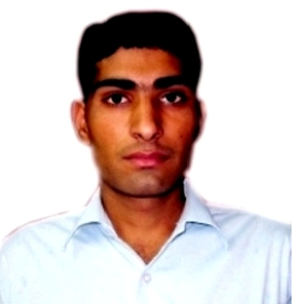
CURRICULAM VITAE
Mukesh Kumar

Email: mukbeniwal1989@gmail.com

Phone: 9106995263/8460805332
LED PROFESSIONAL

Energetic Product manager with 7+ year rich experience in delivering highly effective results & business value in high-growth environments in R&D of LED Product across the industry of repute.

SCHOLASTIC PORTFOLIO

B. Tech (Electronics & Communication): 2011

Sobhasaria Engg. College, Sikar, Rajasthan Technical University:69.35%

Higher Secondary Certificate: 2007
Rakesh Academy Sr. Sec. School, Pilani, Ajmer Board Rajasthan:62.62%
Secondary Certificate: 2005

Tagore pubic Sr. Sec. School, Pilani, Ajmer Board Rajasthan:68.83%

EXPERIENCE DETAILS

Viscotex Energy Pvt. Ltd. Mumbai
Feb2017-Till date Product Manager

Development of COB Street Light 20W to 100W

Development of COB High Bay Light 50W to 150W
Development of COB Flood Light 10W to 250W
Development of Multi LED Street Light 20W to 250W
Development of Multi LED High Bay Light 50W to 200W
Development of Multi LED Flood Light 10W to 350W
Development of LED Clean Room Light 25W to 60W
Development of LED Industrial Light 45W to 90W
Development of LED down-Light 3W to 18W

Development of LED Panel Light 3W to 7W
Development of RGB LED down-Light with Remote control 3W to 18W
R&D of DC TO DC LED Buck Convertor(Constant Current LED Driver)
R&D of DC TO DC Constant Current Driver for Emergency Light
R&D of AC TO DC Constant Current Driver for LED Tube Light

Konark Fixture Ltd. Daman & Himachal Pradesh
June2015-Jan2017 Sr. Engineer

Development of LED Street Light 20W to 250W

Development of LED Bay Light 70W to 180W
Development of LED Flood Light 70W to 350W

Development of LED Well Glass 36W to 90W
Development of LED Ceiling Light 36W to 100W
Thermal Study of LED Light Prepare Prototype LED Driver Sample
Thermal management of LED Light
Generate BOM

Make product validation report
Daily LED Production Planning
5S on floor principles and hands on experience of executing projects .
Smooth Operation of Assy. Lines for All LED Light
Responsible for Final inspection of LED Light with Customer
Knowledge of SWM Process and MI Process study to reduce
total rejection of less than 0.2% .

Devshree Electroplast Dadra
April2011 – May2015 R&D Engineer

R&D of LED Plastic Batten Light 9W to 18W
R&D of LED Batten AL Profile Light 9W to 36W
R&D of LED Retro AL Profile Light 9W to 18W
Prepare Prototype LED Driver Sample
Thermal Study of LED Light
Development of LED Panel Light 3W to 7W
Development of LED down- Lighter 3W to 18W
Generate Product Spec and Technical report

Generate BOM
PERSONAL DETAILS: | : 1st July 1989
DATE OF BIRTH | : 1st July 1989
FATHER’S NAME | : Shree Tara Chand
PERMANENT ADDRESS | : Plot No. 274, V&P.O. -Thirpali Bari,
 | Rajgarh, Churu(Raj.)
 | Pin code: 331305
QUALITIES | : Agile & Sincere
LANGUAGES KNOWN | : English and Hindi .

DECLARATION
I hereby solemnly declare that the above mentioned information is correct up to my Knowledge and I bear the responsibility.

Place: ______________ | (Mukesh Kumar)
Date: ______________

